**Life Expectancy Using Machine Learning**

* **Introduction :-** Life expectancy is a measure of various factors that determine the expected number of years a person is predicted to live. There are mainly two kinds of life-expectancy evaluations to be done according W.H.O
  1. **Overview :-** Regression Machine Learning project analyses historical data predict insights into the future. This problem statement is aimed at predicting Life Expectancy of an average person of a country on basis of given features.
  2. **Purpose :**-Life expectancy is a statistical measure of the average time a human being is expected to live, Life expectancy depends on various factors: Regional variations, Economic Circumstances, Sex Differences, Mental Illnesses, Physical Illnesses, Education, Year of their birth and other demographic factors. This problem statement provides a way to predicting average life expectancy of people living in a country when various factors such as year, GDP, education, alcohol intake of people in the country, expenditure on healthcare system and some specific disease related deaths that happened in the country are given.

Example :- Life expectancy at age 60 (years) The average number of years that a person of 60 years old could expect to live, if he or she were to pass through life exposed to the sex- and age-specific death rates prevailing at the time of his or her 60 years, for a specific year, in a given country, territory, or geographic area.

* **Literature Survey :-**
  1. **Existing Problem :-**
     + Life expectancy at age 60 (years) The average number of years that a person of 60 years old could expect to live, if he or she were to pass through life exposed to the sex- and age-specific death rates prevailing at the time of his or her 60 years, for a specific year, in a given country, territory, or geographic area.
     + This problem statement provides a way to predict average life expectancy of people living in a country when various factors such as year, GDP, education, alcohol intake of people in the country, expenditure on healthcare system and some specific disease related deaths that happened in the country are given.
  2. **Proposed Solution :-**
     + Designing a Regression model which will predict continuous values output for life expectancy of an average person living in a particular country with help of the given feature such as year, GDP, BMI, alcohol intake on person living in a country ,average expenditure of people on healthcare, some average deaths due to specific diseases etc.
* **Theoretical Analysis :-**
  1. **Block Diagram :-**

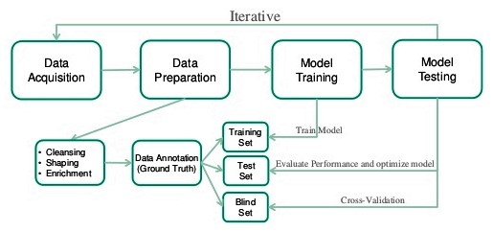

* 1. **Hardware And Software Designing:-**
     + **Hardware:-**
       1. Desktop or laptop with i3 or greater processor.
     + **Software:-**
       1. Python 3
       2. Jupyter Notebook
       3. IBM cloud
       4. IBM Watson Studio
       5. IBM Watson Machine Learning API
       6. Nodered
* **Experimental investigation:-**
  1. Understanding the problem statement.
  2. Collecting the dataset from the Kaggle.com(url:-“ <https://www.kaggle.com/kumarajarshi/life-expectancy-who>”).
  3. Data analysis.
  4. Data preparation and cleaning.
  5. Splitting the data into training and testing data.
  6. Selecting the regression model for the dataset.
  7. Implementing the model.
  8. Testing the model.
  9. Predicting label using the features required.
* **Flowchart :-**
* **Result :-**

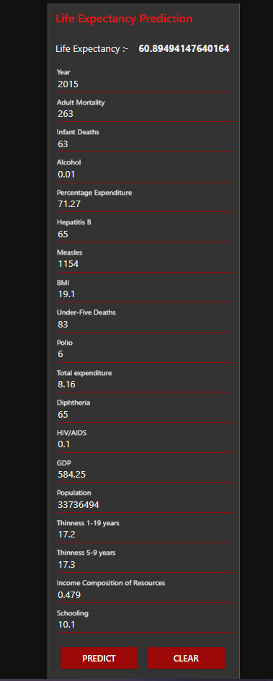

Using the Linear regression model ,on giving required feature we can predict the life expectancy of country . In above example ,on providing above specified values we get that a particular person in a country can live on an average for 61 years .

* **Conclusion :-** The Linear regression model used for predicting life expectancy using machine learning, predicts that how much a person on an average will live in certain conditions. It creates the regression line which is a best fit line depending upon training data given on that basis when we provide different feature values it can provide us with almost accurate result .

Hence, we can easily implement and use the linear regression model to predict life expectancy using machine learning.

* **Future Scope :-** The model can be made adaptable to very large set of data. It should be upgraded such that it can become more reliable, accurate and compatible with incomplete data. The model should be updated so it can be used for non-linear data.
* **Bibliography :-** 
  1. <https://stackabuse.com/linear-regression-in-python-with-scikit-learn/>
  2. <https://bookdown.org/caoying4work/watsonstudio-workshop/jn.html>
  3. <https://developer.ibm.com/technologies/machine-learning/series/learning-path-machine-learning-for-developers/>
  4. <https://www.kaggle.com/kumarajarshi/life-expectancy-who>
* **Appendix :-** 
  1. UI :- <https://node-red-unhrx.eu-gb.mybluemix.net/ui/#!/0?socketid=WuTwrfFwmQLNASs6AAAK>
  2. Code :- <https://github.com/Shubham7496/llSPS-INT-1613-Predicting-Life-Expectancy-using-Machine-Learning>